Cost and Weight Reduction of Structural Sandwich Applications
for the Aerospace Industry by the use of a new high performance, high temperature resistant and damage tolerant Core Material

Fabio Tufano¹⁾, Dirk Roosen²⁾, Uwe Lang³⁾, Dr. Kay Bernhard⁴⁾, Dr. M. Alexander Roth⁵⁾
- New Business Development South America, High Performance Polymers, Evonik Degussa Brasil Ltda
- Head of Market Segment ROHACELL® Aircraft, High Performance Polymers, Evonik Resource Efficiency GmbH
- Sandwich Technology ROHACELL®, High Performance Polymers, Evonik Resource Efficiency GmbH
- Head of R&D Performance Foams, High Performance Polymers, Evonik Resource Efficiency GmbH
- VP of Evonik Foams Inc. & Director of ROHACELL® Americas, Evonik Foams Inc., Evonik Corporation

Abstract: A new structural Polymethacrylimide (PMI) grade as core material for sandwich structures has been developed to meet the demands of the aerospace industry. The existing PMI foam was modified to give it a more ductile and robust behavior. The paper describes the background of the development and the testing to prove the concept in a full business case. For the case study, a nose landing gear (NLG) door was selected. In the first stage, mechanical properties of the new grade were determined. Besides the standard mechanical tests of compressive, shear and tensile strength tests, it was also tested for impact and fatigue. Freeze and thaw testing were performed at an impact damaged area, in order to determine the growth of the damaged area. Thermal cycling loading tests from -55 °C (-65 °F) to 72 °C (160 °F) were performed for 2000 cycles to determine the influence of the temperature loads. Fracture toughness tests at RT and -55 °C (-65 °F) were performed, to determine the skin to core adhesion in a load case. These tests, lead to the building of a complete NLG door, in order to compare the production time, economical aspects and weight of the component, in comparison to the conventional classic method of using honeycomb core. Finally, the NLG door was exposed to a bird strike impact test in order to verify the integrity of the new system. To facilitate material changes and qualifications, the new PMI grade was specifically engineered to meet customer specifications and provide advantages such as part weight reduction up to approx. 20 % and unit production cost savings up to approx. 25 %.
Key words: PMI foam; core material; sandwich structure; structural; Aerospace; cost savings, weight savings.

INTRODUCTION
Enhancement of our environment is an important driver for innovation. Lightweight construction reduces the consumption of resources and energy. It has to fulfill demanding mechanical as well functional requirements with less weight. Playing a major role in this area, sandwich structures combine a lightweight core with two thin layers of fiber-reinforced composite material. The outer layers, separated by the core, give the component the required strength and rigidity. The result is a lightweight structural part that provides the highest mechanical performance at minimum weight. With high stiffness-to-weight ratio compared to monolithic structures, sandwich constructions are widely used in aerospace applications.
ROHACELL® is a family of closed-cell Polymethacrylimide foams that are ideally suited for strong and lightweight sandwich construction. PMI structural sandwich foam cores offer the highest level of specific stiffness and strength, good fatigue properties, high temperature resistance (up to 230 °C/ 446 °F) and unsurpassed resistance to compressive creep at elevated temperatures.
Although PMI foams are successfully used in many different areas of an aircraft, there have been limitations to use as a “structural foam” in applications where it is subjected to extreme temperature fluctuations and high levels of mechanical stress (impact), such as in certain components on the exterior of an aircraft. At altitude of up to 10,000 meters (33,000 feet), temperature fall below -55 °C (-67 °F). The polymers must exhibit high elongation at break at these extreme temperatures, in order to withstand the resulting stresses. However, if damage occurs, for safety reasons this must be obvious and easy to detect visually on components such as wings, landing gear doors, fairings or rudders.
Damage can be caused, for example, by a bird strike or by foreign objects being hurled up from the runway. The tough, elastic core of structural foam can support the outer layer in the event of an impact and hold it firmly in place if plastic deformation occurs causing a dent to the foam.
The objective was to modify the PMI chemistry to increase robustness without having an adverse effect on strength. At the same time, the homogeneous fine cell structure and the high temperature stability of the material must remain unchanged.
This paper summarizes the testing and proof of concept for the newly developed grade. It will be shown that significant improvements regarding damage detection, and damage tolerance can be achieved. Furthermore it will be shown that the new Grade is more ductile, compared to the already existing grades, but still offers unsurpassed specific material properties.

Changing the Physics

Changing the elongation at break
The target of the modification was, to increase the ductility/robustness of the mechanical performance. The goal of the comprehensive R&D work, was aimed at increasing the elongation at break, without changing the other mechanical properties like compressive-, shear- or tensile strength. The effectiveness of different curing agents from the Group's portfolio were tested in extensive laboratory experiments. Normally, curing agents inhibit foaming, as they link molecular chains with each other during polymerization and counteract the formation of pores. This effect was largely leveled out with suitable types and quantities of curing agent and through cleverly coordinated control of the processes and reactions. By adding an additive, based on plasticizer basis and several fillers, the elongation at break was influenced in the right way. The mechanical properties stayed on a high level, whereas the ultimate elongation tripled (Figure 1).
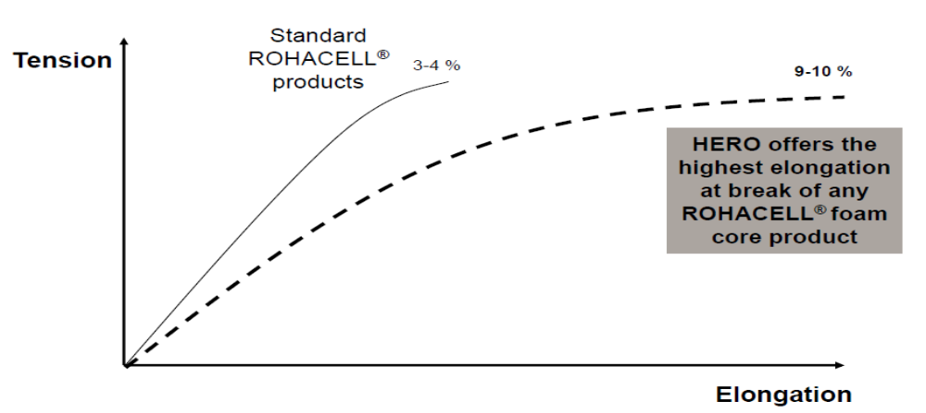
Figure 1: Elongation at break of the new grade, is three times higher than with other PMI products

Experimentation

Testing of mechanical properties
The standard mechanical properties were tested under room temperature, extended temperature and under climate chamber condition. Below are the standard mechanical properties for a general overview. These compare very well with the standard values for PMI foams. Except the compressive strength is on a lower level, whereas the tensile strength is on a much higher level.
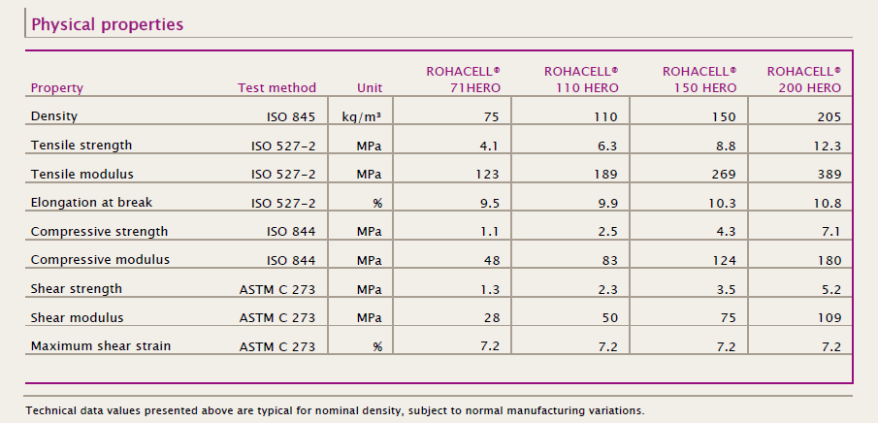
Table 1: General overview of standard mechanical properties

Freeze and thaw testing
If an impact is made to a honeycomb core sandwich structure and it is not detected immediately, the core is exposed to the environment. In the worst case, it can get filled up with water. When the aircraft is reaching, its cruising altitude with temperatures below the freezing point, water will turn into ice and demand space. When this occurs, there is a huge risk of delamination that can result in a total failure/ damage of the part.
With the closed-cell PMI, only the damaged cavity could fill with water, but proof that damage stays local, is also needed. The test was performed under laboratory conditions. A sandwich panel was impacted, so that the face sheet and the core were destroyed in a local area. Water was filled in the cavity (see Figure 2) and the surface sealed again.
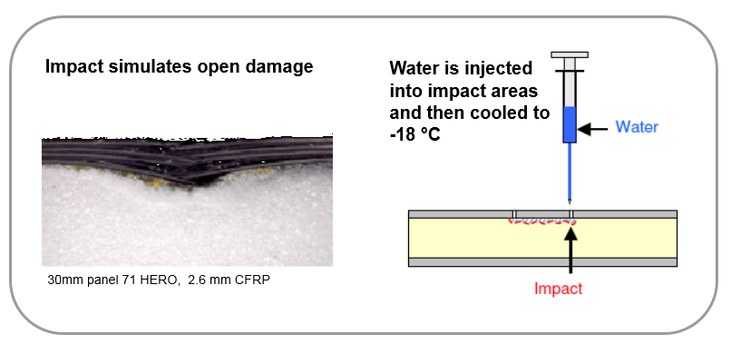
Figure 2: Freeze and thaw testing – test setup

The damage area was NDT controlled by C-scan in order to judge the damage size. The test series started with a series of freeze and thaw cycles from room temperature to -18 °C (-0,4 °F). The size of the damage area was inspected after 6, 30 and 60 cycles (see Figure 3). The results of this test showed no damage growth during cycling. The new ductile PMI grade absorbed the change in volume during the liquid to solid transition phase of water.
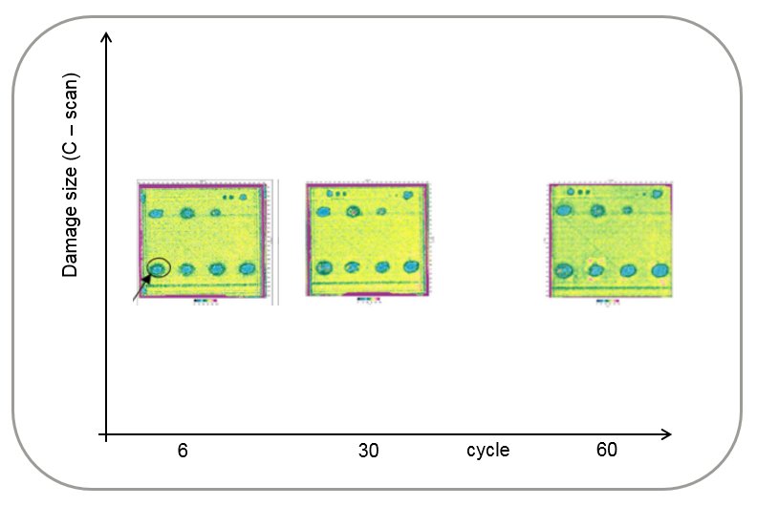
Figure 3: Freeze and thaw testing – test results after cycling shows no growth of the damage area

Thermal cycling loading tests
Composite parts are also exposed to high temperature cycles. Parts that are manufactured up to 180 °C (356 °F) will see an in-service temperature change from -55 °C (-67 °F) up to 72 °C (162 °F) again. The PMI foam must exhibit high elongation at break at these extreme temperature variations in order to withstand the resulting thermal residual stresses caused by different thermal properties of the used sandwich materials. A sandwich panel was built at 180 °C (356 °F) and thermally loaded 2000 cycles from -54 °C (-65 °F) to 72 °C (162 °F). The panel was controlled by C-scan and no influence due to thermal cycling load was found.

Fracture toughness tests [1] [2]
In service, sandwich parts are under stress caused by the operating load. This transfers to the core mainly shear stress and for the skins in-plane tensile or compression stress. A worst case scenario, will be a debonding area due to a manufacturing defect, an impact during takeoff/ landing procedure or a tool drop during maintenance. This can lead to separation from skin to core and a “loss” of the part. The bond line between the core and laminate must be strong enough to restrict, in case of local damage, the laminate from peeling off the core. This fracture toughness behavior (G_{1C}-value) is influenced by the cell size, resin and core ductility and core tensile strength. Tests were performed under room temperature and -55 °C (-67 °F) with a single cantilever beam (SCB) test (see figure 4).
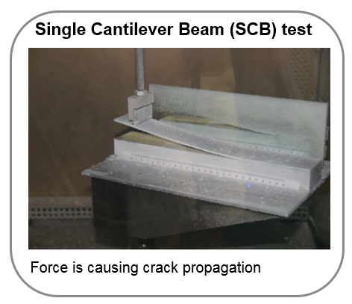
Figure 4: Single cantilever beam test

The local buckling load G₁ is calculated by FEM (Finite Element Method) to determine the skin to core failure load for a typical aircraft part, e.g. flight control surface. The G₁ force is a function of damage size, skin stiffness and in-plane compression. With the SCB test, the loads were determined at room temperature and more critical -55 °C (-67 °F). In Figure 5, the test results are shown. The G₁ load determined by FEM is below the actual skin to core failure load G_{1C}. If G₁ < G_{1C}, there is no crack propagation. In this case we find a safety factor of at least 2 for the -55 °C test condition.

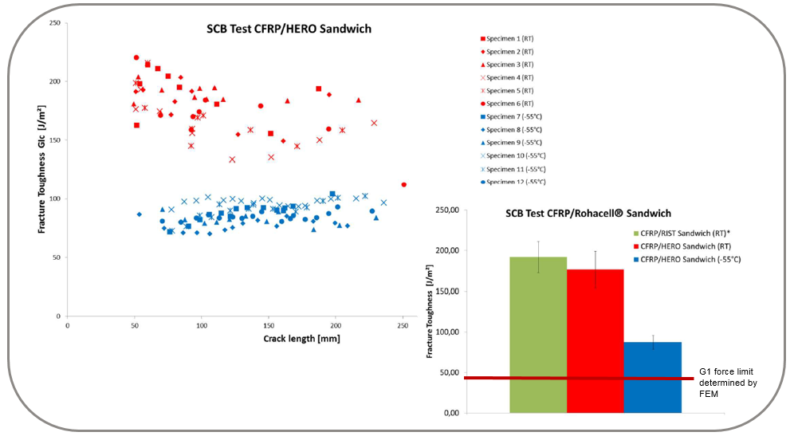
Figure 5: G_{1C} values from single cantilever beam test

Flat wise tensile test
Another method to determine the core to laminate bonding is ASTM C297 flatwise tensile test. Sandwich test coupons are bonded to steel plates (see Figure 6). All samples failed by core failure. This proves that the bonding stability is higher than the actual core tensile strength.
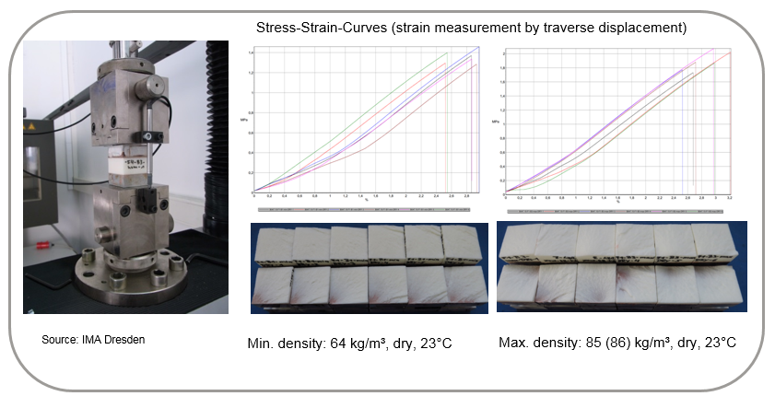
Figure 6: Flatwise tensile test according to ASTM C297

Fatigue testing [3]
Fatigue 4-Point Bending testing was performed under ASTM C 393 to prove long term durability (see Figure 7).
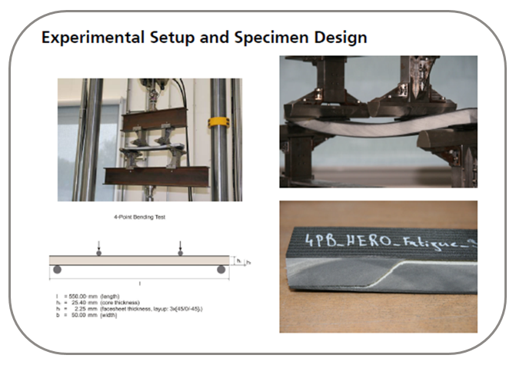
Figure 7: Fatigue 4-Point Bending Test according to ASTM C 393
The test specimen was tested up to 5 million test cycles under dynamic load (see Figure 8). The new PMI grade can be loaded with ~55 % of its actual quasi-static ultimate bending load. To determine the residual strength after 5 million cycles, the test specimen was tested again in a quasi-static 4-Point Bending test. It failed under the same load as the not cycled specimen, so no degradation was found.

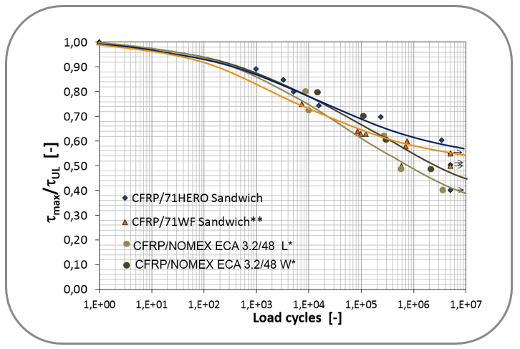
Figure 8: Fatigue test results after 5 Million test cycles

Impact testing [4]
Impact tests were performed under ASTM D7766 to determine the visibility and the damage size caused by the impactor. The newly developed PMI core was compared with a Nomex Honeycomb (HC) filled system. The impactor diameter was 25,4 mm (1”). The test was performed under room temperature, at -55 °C (-67 °F) and at different impact load levels. See test results in Figure 9.
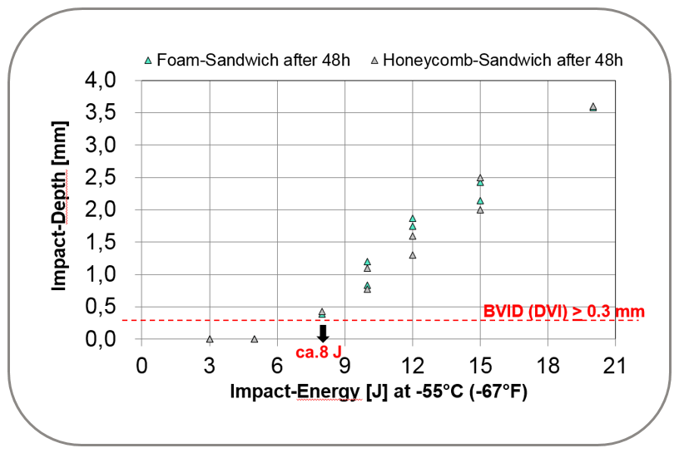
Figure 9: Impact Depth vs. Impact Energy at -55 °C (-67 °F)

The barely visible impact damage limit is at ~8 J. The impact behavior of the HC and the PMI cored sandwich is quite similar from a visible point as well from the size of the failure area. See below in Figure 10.
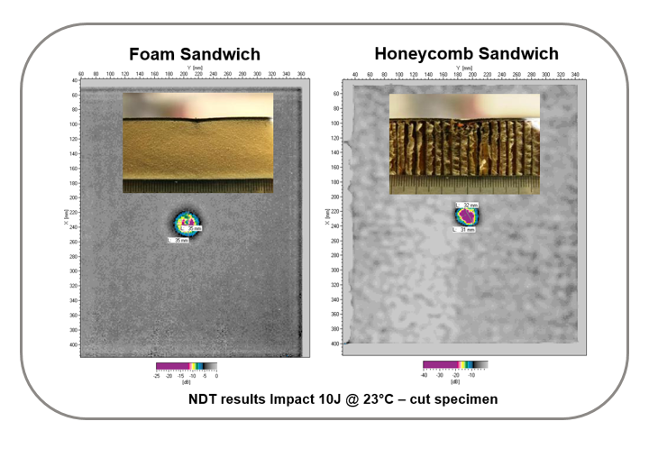
Figure 10: Size of damaged area determined by NDA and view of cross section.

Results and discusion

Evaluation of the production parameter and economical aspects by building a nose landing gear door [5]
All these tests performed led to the building of a complete NLG door with 71 HERO (75 kg/m³) using both prepreg/autoclave and out-of-autoclave (infusion) technology in order to compare the production time, economical aspects and part weight in comparison to a NLG door with Nomex honeycomb core (64 kg/m³) using conventional prepreg/autoclave process only. Finally, the nose landing gear door was exposed to a bird strike impact test in order to verify the integrity of the new system.
The part is shown in Figure 11 and was an original part of the Dornier Fairchild 728 NLG door.
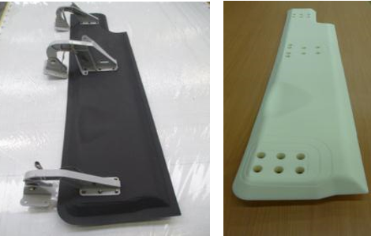
Figure 11: Dornier Fairchild 728 NLG door – demonstrator door

A new design of the core material was applied in co-operation with the CTC (Composite Technology Center Stade, a subsidiary of Airbus Operation GmbH) and built at INVENT (Spin-off of DLR Braunschweig – German national aeronautics and space research center). By building the door, the exact parameters including material usage, time for preparation and final NDT were determined. See a breakdown of the different process steps in Figure 12.
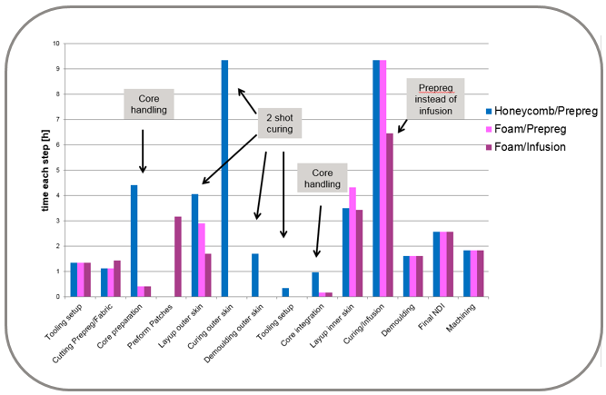
Figure 12: Comparison of different process steps to build up the NLG door.

Over all, the economical aspect was interesting and is shown in Figure 13. The material cost analysis shows higher costs for the PMI foam versions, which could be easily compensated by saving production time and costs for additional adhesive and edge closing materials needed to stabilize HC core. Overall, the production costs of the PMI cored NLG doors could be reduced by up to 25 % compared to Nomex HC core. In addition to this, the weight of the NLG door with PMI foam is up to 19 % lighter as a result of leaving out the added adhesive film and the potting required by honeycomb designs.

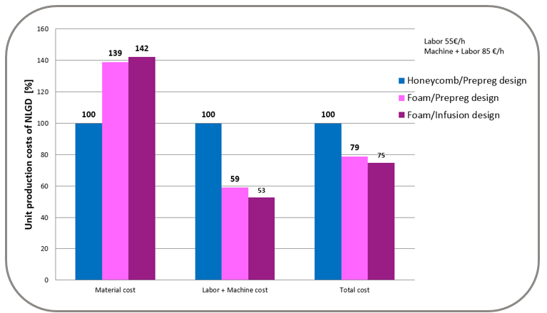
Figure 13: Cost comparison of the NLG door.

Bird strike test
To prove the weight and cost optimization of the NLG door for the main load case, the part must pass a typical bird strike test. For this test, the door was shot at a 15° angle with a 1,8 kg bird dummy at a speed of 540 km/h. The test was performed at DLR in Stuttgart, Germany (see Figure 14). The test was passed with local delamination only and the part could still withstand reduced aerodynamic loads.
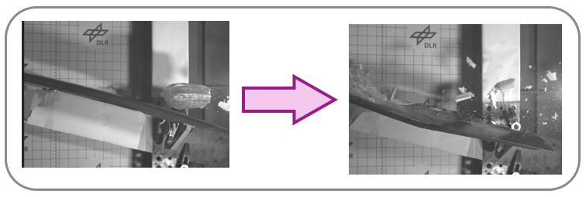
Figure 14: Bird strike test at DLR in Stuttgart, Germany

Conclusions
The latest developed PMI foam (ROHACELL® HERO), sets a new milestone for structural foam cores in aerospace applications.
This paper proves, with all described tests, the structural function of this foam core in worst case conditions and worst case damage scenarios. All these tests follow the building-block approach and are a reference for the suitable core material and sandwich behavior for the aerospace industry. Consequently further detail and part tests are needed. Substituted for a real part test, the most critical load test (bird strike) was conducted and the part passed the requirements.
With the ductile behavior, resulting in damage tolerance and visibility, the important damage behavior is proven robust and detectable. With the modification of the robust ductile behavior, it is important that the new PMI core can still be used in a “one shot cure cycle” manufacturing process. This allows efficient part production and reduction of required human resources, as well as saving e.g. autoclave operation time. Factors that, when combined, can lead to potential cost savings of up to 25 % over the conventional classic method of using honeycomb. The weight of the part can be reduced significantly as well, by avoiding additional adhesive and potting compound, which was shown in the business case with a weight reduction of up to 19 %. The new grade is currently under qualification at several OEMs in different regions and is scheduled to be established in a first series application in 2016.

References
[1] NASA/CR-2002-211628 ICASE Report No. 2002-10/Ronald Krueger ICASE, Hampton, VA
[2] Single Cantilever Beam Tests with CFRP/HERO Sandwich Facesheet/Core Fracture Toughness Evaluation / Fraunhofer IWM Halle M. Rinker / Saale / July 2013
[3] 4-Point Bending Tests with CFRP/HERO Sandwich / Evaluation of the Foam Core Shear Fatigue Performance Fraunhofer IWM Halle M. Rinker / Saale / November 2013
[4] Damage Tolerance Behavior: Impact Resistance PMI-Foam ROHACELL® HERO vs. Nomex -Honeycomb Sandwich / Fraunhofer IWM Halle M. John / Saale / September 2013
[5] NLG-Door Final Report / Composite Technology Center Stade / B. Leohold, K. Schubert, J. Born, R. Hinz / Ref. 1225-004 Issue V02 / July 2014

